Project Design Phase
Solution Architecture
Date | 04 September 2026
Student Name | Pulibanti Tejavani
Project Name | Metro Ticket Generating System
Maximum Marks

Solution Architecture
The solution architecture connects the passenger-facing ServiceNow portal with the metro ticket booking configuration, fare calculation logic, payment handling, QR generation, and backend station and ticket data. The architecture is designed to provide a guided booking process while maintaining accurate ticket information. 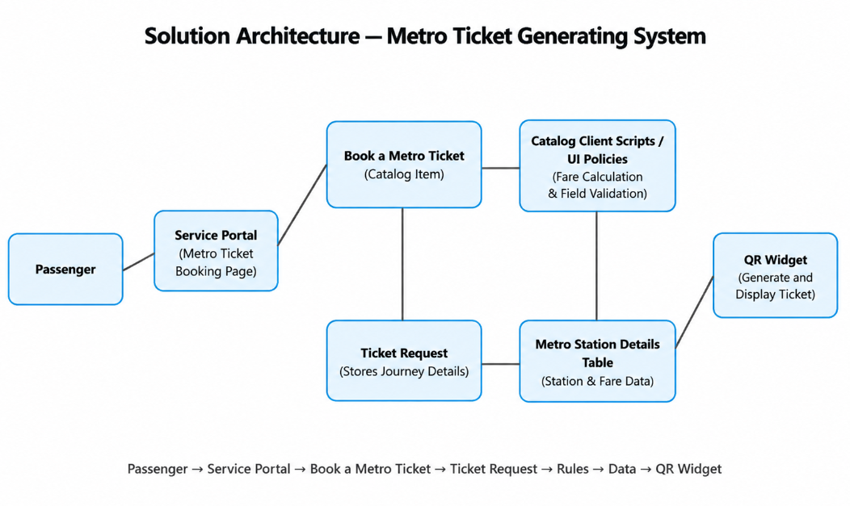
Figure 1: Employee Raise Issue solution architecture.
Layer | Components | Responsibility
Experience | Service Portal, Metro Ticket Booking page, QR Widget | Provides the passenger-facing booking experience.
Interaction | Catalog Client Scripts | Handles dynamic form behaviour and automatic fare calculation.
Catalog | Book a Metro Ticket Catalog Item, Variables | Collects journey, passenger, fare, and payment information.
Rules | UI Policies, dependent choices, validation logic | Controls field visibility, mandatory fields, and valid selections.
Data | Metro Station Details table, Ticket/Request data | Stores station information and submitted ticket details.
Integration / Output | QR Widget, QR generation logic | Generates and displays the digital QR ticket after submission.

